BRISTON PARISH COUNCIL
The Parish Office
Briston Pavilion, Recreation Ground,
Stone Beck Lane, Briston,
Melton Constable NR24 2PS
Telephone: 01263 862638
Email: parish-council@briston-norfolk.org.uk
Website: http://bristonparishcouncil.org/1&1

To: All Councillors

From: The Clerk

There will be a meeting of Briston Parish Council on Monday 1 March 2021 at 7pm on Zoom for the purpose of transacting the following business only. Zoom codes for this meeting: The Zoom code is: Meeting ID: 893 4738 0165. Passcode: 707990
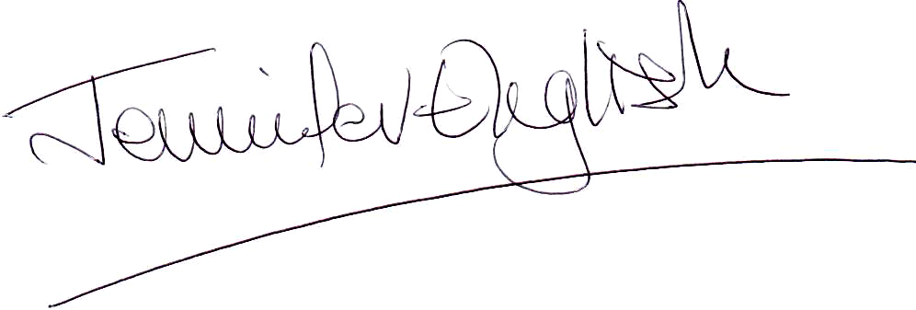
23 February 2021

Please note this is a virtual meeting in line with the Coronavirus Bill. This allows for virtual meetings until May 2021.

MEMBERS OF THE PRESS AND PUBLIC ARE WELCOME TO JOIN THIS MEETING

AGENDA

1. To consider and accept apologies for absence
2. To record declarations of interest from members of any items on the agenda
3. To approve the minutes of Briston Parish Council meeting held on Monday 1 February 2021
4. To invite public participation including reports from County Councillor, District Councillor and SNT representative
5. To discuss matters arising from the minutes of Briston Parish Council meeting held on Monday 1 February 2021
6. To consider and make observations on any planning applications which may be received
7. To discuss and approve the design, print and costs of the information panels and footpath leaflets for six walks – Footpaths Subcommittee
8. To approve the purchase of 10 information boards for the village green
9. To award the grass cutting contract for the open spaces in Briston for the cutting season running from the end of March to the end of October 2021
10. To approve the costs of upgrading five street lights in The Lane
11. To discuss whether to hold the Annual Parish Meeting and if so where, when and how
13. To discuss setting up a small working group to make initial proposals to the parish council with regard to celebrating the Queen’s Platinum Jubilee in June 2022
14. To discuss and approve a proposal that ownership of the former railway bench be transferred from the Higginbottom Recreational Charity to Briston Parish Council
15. To discuss and approve proposal to add one more camera to the parish office CCTV system to cover the back of the Briston Pavilion

16. To discuss a proposal to change the dog waste bins into dual litter/dog bins and to change the emptying of all litter bins to North Norfolk District Council waste collection service as a more cost effective solution and one which gives the handyman more time for other tasks – Cllr Mrs Woodhouse
17. To approve the Parish Council action plan to run from April 2021 – Cllr Graham Pickhaver
18. To discuss and approve a proposal to separate insurance for the Briston Pavilion from Briston Parish Council’s insurance
19. Clerks Report
Update on work carried out on the dip on the village green
Update on progress of allotment rent demands
Update on progress of NALC health check
Update on proposals to install a play area on the open space behind Jewel Close
Thank you email from Briston Salvation Army
20. To review the asset register, make amendments if required and approve
21. To approve the bank statement for February and the payments for March 2021
22. To receive a report from the Copeman Centre – Cllr Mrs Woodhouse
23. To invite public participation
24. Any other business including items for the April agenda. For discussion only. No items can be approved under this item
25. Date of next scheduled meeting – Monday 12 April 2021

