BRISTON PARISH COUNCIL
The Parish Office
Recreation Ground, Stone Beck Lane,
Briston, Melton Constable NR24 2PS
Telephone: 01263 862638
Email: parish-council@briston-norfolk.org.uk
Website: http://bristonparishcouncil.org/1&1

The next meeting of Briston Parish Council will be held on Monday 11 March 2024 in the Copeman Centre at 7pm for the purpose of transacting the following business only.

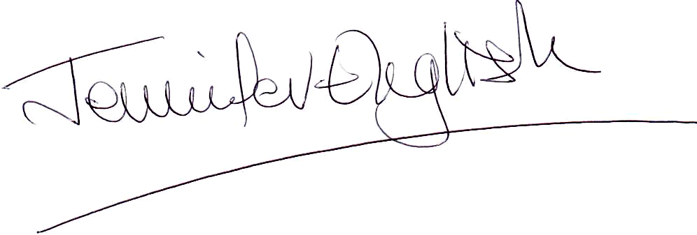
Clerk Briston Parish Council
5 March 2024

MEMBERS OF THE PRESS AND PUBLIC ARE WELCOME TO ATTEND

AGENDA

1. To receive and accept apologies for absence

2. To record declarations of interest from members on any items on the agenda

3. To approve the minutes of the meeting held on Monday 12 February 2024

4. To invite public participation including reports from the County Councillor, District Councillor and SNT representative

5. To discuss matters arising from the minutes of the Briston Parish Council meeting held on 12 February 2024

6. To consider and make observations on the following planning applications and any more which may be received:
Mollys Cottage, 149 Hall Street, Briston, Melton Constable, Norfolk NR24 2LQ
Detached dwelling house with access and associated works
130 Hall Street, Briston, Melton Constable, Norfolk NR24 2LQ
Erection of single-storey front extension
12 Mill Road, Briston, Melton Constable, Norfolk NR24 2JF
Replacement dwelling

7. To set up a Personnel Committee for Briston Parish Council

8. To discuss and award the grass cutting contract for 2024 for the open spaces owned by Briston Parish Council and the churchyard and Salvation Army

9. To approve a request for the Little Seaford Truck to set up regularly on the village green

10. To discuss a request for the Gala Working Party for a payment from the parish council of £1,500 towards costs

11. To approve the purchase of two D-Day flags of Peace

12. To approve applying for a free portrait of King Charles III to hang in the Parish Office

13. To discuss the allotment waiting list

14. To discuss the provision of a dog waste bin in Ridlands Road

15. To approve the bank statement for February, the reconciliation and the payments for March

16. To approve a report from the Higginbottom Recreational Charity

17. To receive a report from the Copeman Centre

18. To invite public participation

19. Any other business including items for the April meeting of Briston Parish Council. This item is for discussion only and no decisions on items not on the agenda can be made

20. The next scheduled meeting of Briston Parish Council will take place on Monday 8 April 2024

