BRISTON PARISH COUNCIL
The Parish Office
Recreation Ground, Stone Beck Lane,
Briston, Melton Constable NR24 2PS
Telephone: 01263 862638
Email: parish-council@briston-norfolk.org.uk
Website: http://bristonparishcouncil.org/1&1

The next meeting of Briston Parish Council will be held on Monday 8 April 2024 in the Copeman Centre at 7pm for the purpose of transacting the following business only.
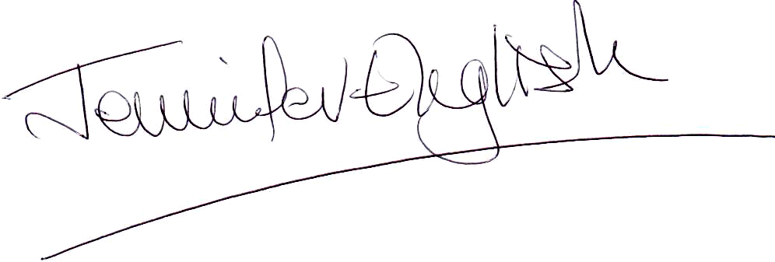
Clerk Briston Parish Council
2 April 2024

MEMBERS OF THE PRESS AND PUBLIC ARE WELCOME TO ATTEND

AGENDA

1. To receive and accept apologies for absence

2. To record declarations of interest from members on any items on the agenda

3. To approve the minutes of the meeting held on Monday 11 March 2024

4. To invite public participation including reports from the County Councillor, District Councillor and SNT representative

5. To discuss matters arising from the minutes of the Briston Parish Council meeting held on 11 March

6. To consider and make observations on any planning application which may be received

7. Further to receiving costings from North Norfolk District Council to discuss and approve the purchase of a dog waste bin for Ridland Road, by Cuckoo Bridge

8. To discuss the problem of dog fouling and litter in the village especially on the open spaces and come up with any ideas for ways of solving the problem

9. To discuss and approve the purchase of a card reader machine

10. To discuss and approve Phat Khao food wagon setting up on the village green on 22 May and then once a month from September onwards.

11. To discuss a request by the Coastal Community Supermarket to operate from the Briston Pavilion for one and a half hours once a week

12. To set up a Personnel Committee

13. To discuss and look into the appointment of a contractor to handle the parish council’s website

14. To approve the appointment of Mr J Graves as the internal auditor for the 2023/2024 financial year

15. To appoint an internal monitoring officer

16. To approve the bank statement for March and the payments for April and the reconciliation

17. To receive a report from the parish clerk with regard to:
Annual parish meeting
Village Handyman
Office cleaner
Co-option process for new councillors
AGAR process

18. To receive a progress report on the Briston Gala

19. To receive a report from the Higginbottom Recreational Charity

20. To receive a report from the Copeman Centre

21. To invite public participation

22. Any other business including items for the May meeting of Briston Parish Council. This item is for discussion only and no decisions on items not on the agenda can be made

22. The next scheduled meeting of Briston Parish Council will be the Annual Parish Council meeting and will take place on Monday 13 May 2024.

